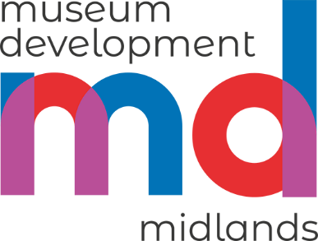 | 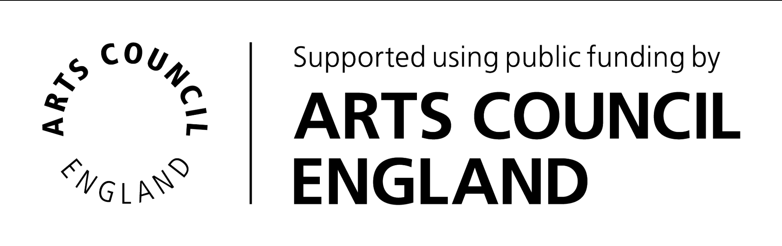 | 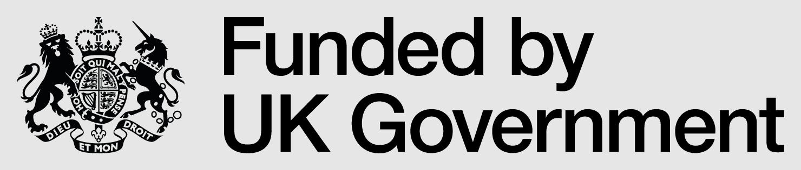

Museum Learning & Engagement Grant application form 2026-27

Section 1: Introduction
Contents:
SECTION 1: Introduction
SECTION 2: Project Overview
SECTION 3: Impact
SECTION 4: Finance
SECTION 5: Agreement and Declaration

Estimated time to complete this form is 60-75 minutes
The full guidance for this grant is available on our website. Please read this guidance before completing your application.
This offline version of the application form can be used to draft your answers and plan your application but must not be submitted. All applications must be completed and submitted via the online form.
A note on the use of AI: Applicants may use AI tools to help draft their applications, but we advise doing so cautiously. You remain fully responsible for all submitted content and must ensure it reflects your own original ideas and complies with data protection and organisational values. Arts Council England's full statement on AI use can be found here: https://www.artscouncil.org.uk/ai-arts-council-england-public-position-statement-writing-and-assessment-funding-applications

Section 1: Applicant details
Your name:
Your position:
Museum name:
Museum post code:
Museum address line 1:
Museum address line 2:
Museum address line 3:
Contact email:
Telephone number:
Museum governance type (e.g. Local Authority, Independent, University):
Name of museum governing body (if different from museum name):

1.1 Please provide an additional named contact, senior staff member or trustee who can be contacted about the project.
Secondary Contact name:
Secondary Contact position:
Secondary Contact email:

1.2 Museum Accreditation Status:
Accredited (Full/Provisional Accreditation)
Working Towards Accreditation
Museum Accreditation Number:

1.3 Size of the museum – visitor number per annum:
Micro (<10k visitors)
Small (10-20k visitors)
Medium (20-50k visitors)
Large (50-100k visitors)
Largest (>100k visitors)

1.4 ACE National Portfolio Organisation (NPO) Organisations
Is your museum part of a museum service which receives ACE National Portfolio Organisation (NPO) funding?
Yes
No
(If yes) Name of NPO funded Museum Service:
1.5 Project delivery area
We will prioritise applications for work in Cultural Priority Places (CPPs). However, you may still apply for a grant if your museum or education provider is based outside these areas. In these cases, we encourage you to provide evidence of low cultural engagement and high deprivation in your area, where available, to help demonstrate need and strengthen your application. You can include this information in Section 2.9 of this application.

1.6 Where will your project activity take place?
(Please tell us the local authority area(s), town(s) or geographic area(s) where you will deliver the project)

1.7 DCMS Culture Priority Places
 | Yes | No
Is your organisation located in a DCMS Culture Priority Place (CPP)?
Are you planning to deliver activity to primary, secondary or sixth form settings (including special schools/colleges) or home education groups in a DCMS Culture Priority Place?

If you answered ‘Yes’ to either question above, please specify the main DCMS Culture Priority Place that will benefit from this project.
 |  | Ashfield |  |  | North East Derbyshire
 |  | Bassetlaw |  |  | Nuneaton and Bedworth
 |  | Bolsover |  |  | Redditch
 |  | Boston |  |  | Sandwell
 |  | Cannock Chase |  |  | Stoke-on-Trent
 |  | Chesterfield |  |  | Telford and Wrekin
 |  | Dudley |  |  | Walsall
 |  | East Lindsey |  |  | West Lindsey
 |  | Erewash |  |  | Wolverhampton
 |  | Mansfield

1.8 Essential criteria

Please confirm that your organisation meets the essential criteria for this grant. Tick to confirm you meet each requirement:
Yes
Organisation is a Midlands based museum which is Accredited or Working Towards Accreditation
The organisation must be able to provide evidence of grant expenditure by 31 March 2027. This must include evidence of any backfill arrangements and costs, additional contracted hours, overtime payments, or increases in PAYE staff costs funded through the grant. additional contracted hours, overtime or increases in PAYE staff spend.
Organisation confirms that it can complete and submit all project activity and reporting to MDM by 17 May 2027.
Activity funded by this grant will be new activity.
Proposed activity aligns with at least one of the programme activity areas detailed in Section 5 of the MLE guidance.

Section 2: Project Overview
Project title:
Project start date [DD/MM/YYYY]:
Project end date [DD/MM/YYYY]:

2.1 Project partners

Are there any partners involved in your project? If so, please list them here:

2.2 Learning settings

Which learning settings (primary, secondary and sixth form settings, including special schools/colleges and home education groups) will be involved in the project? Please list them here:

2.3 Engagement with learning settings
Have these organisations or groups been informed about the potential project activity at the time of submission? (education providers must have been informed about the potential project activity at the time the application is submitted if the applicant is planning to enter into a formal development partnership with them)
Yes

No

2.4 Summary of activity (max 50 words)

2.5 Project aims and measurable outcomes (list up to 5):
Outcome 1:
Outcome 2:
Outcome 3:
Outcome 4:
Outcome 5:

2.6 Developing learning and engagement activity

MLE Grant Aims: Which of the following Museum Learning and Education Grant aims does your project address? (Refer to section 5 of the MLE guidance for examples)
a) Developing learning and engagement
b) Improving access, participation and enrichment
c) New ways of working
d) Building evidence for the future
e) Building organisational capacity

2.7 Please explain how this project represents new activity or a new approach for your museum (max 100 words)

2.8 Detailed project description (max 300 words)

Describe your project in detail, including key activities, how they will be delivered, and who will be involved.

2.9 Rationale and need (max 200 words)

Tell us why this project is needed and what issues or opportunities it responds to. Please describe the children and young people, communities and learning settings your project will work with, and explain how the project will benefit them. Where relevant, include evidence such as links to DCMS Culture Priority Places and/or evidence of low cultural engagement and high deprivation or other evidence that demonstrates need.

2.10 Capacity to deliver (max 200 words)

Describe how your organisation has the resources, skills, or partnerships to complete the project successfully.

Section 3

3.1 Expected impact (max 200 words)

Describe how the project will strengthen your organisation's ability to improve children and young people’s cultural access, participation and learning outcomes.

3.2 Measuring success (max 200 words)

Explain how you will know if the project has been successful. Include any targets, milestones, or evaluation methods. (Refer to your outcomes listed in question 2.5)

3.3 Project timescale and key milestones (max 200 words)

List the main stages of your project, including dates or approximate timings.

3.4 Freelance and workforce engagement (max 150 words)

How will you ensure fair, transparent and inclusive recruitment and working practices?

Section 4: Finance

4.1 VAT status
(VAT-registered organisations should exclude VAT from costs; non-registered organisations should include it)
Are you or your organisation VAT registered?
Yes
No
4.2 Project cost breakdown
Please download the project cost breakdown form here and use it to list all goods and services to be purchased for the project, showing the total cost, the amount requested from MDM, and any match funding contribution. Also indicate the source of any match funding.
The grant can only cover VAT that you cannot recover from HM Revenue and Customs:
- VAT Registered Museums: Exclude VAT from costs.
- Non-VAT Registered Museums: Include VAT in costs.
You must send us all appropriate invoices and receipts (with VAT or without VAT) when submitting your final accounts.

Please upload your completed project cost breakdown form here:

Note: The maximum amount available varies by grant stream. Applicants should refer to the guidance for the specific maximum applicable to this grant.

4.3 Expenditure totals in £
Total match funding:
Total amount requested from MDM:

We need to see that your costs are appropriate. Please upload any supporting evidence (refer to section 8 of MLE Guidance):

4.4 Have you provided supporting evidence for costs, such as quotes for freelance/consultant support or evidence of material costs over £100 (see guidance for examples of appropriate evidence)?
Yes
No
If ‘no’, provide further detail below. Please note that if you are unable to provide evidence of proposed costs, this may delay your application.

Section 5: Agreement and Declaration
Agreement and Declaration
By submitting this form, you confirm that:
- The information provided is accurate and complete.
- You have read and accept Museum Development Midlands's grant terms and conditions.
- You will provide appropriate evidence of expenditure and evaluation after the project is complete.

Applicant signature
This form must be signed by the CEO, Chair, Director, Museum Manager or Head of Museum Service.

Signed (print name):
Position:
Date:

